Find each customer who ordered items worth more than 30,000. Show customer name, product name, and item amount.

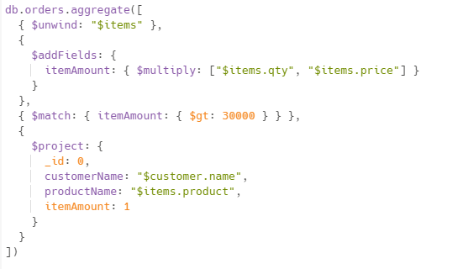

Calculate total amount of shipped orders for each cityand display city and totalAmount fields

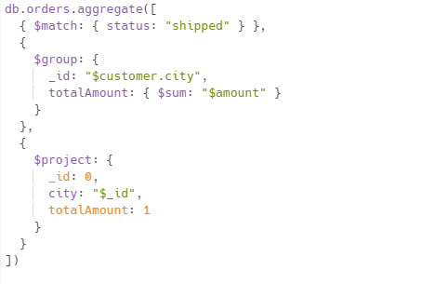

Grouping orders by year and month and display total orders and total amount per month in output

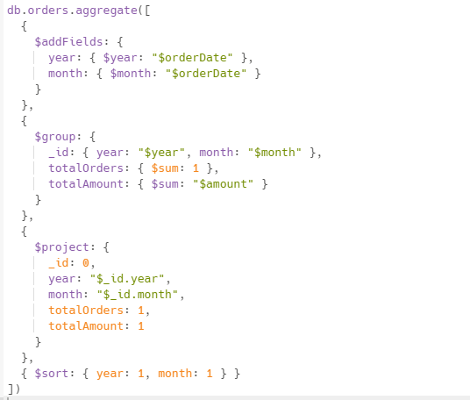

Using facet write these queries: Total number of orders Number of shipped orders Total sales per customer

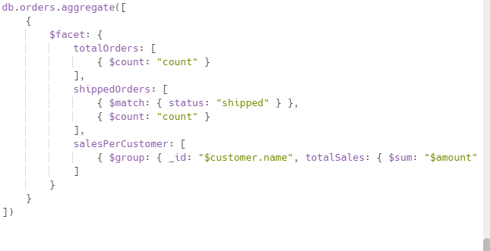

Show only customer name and amount for shipped orders and amount above 30,000

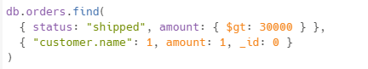

show orders for customers in Delhi or Mumbai and display only name and city fields.

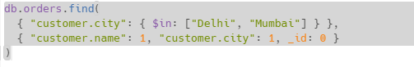

Show orders where total amount is between 20,000 and 50,000

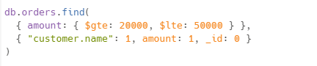

Finding the each customer first and last order

